Forum Web App

By

Rajbir

Level-6

Final Project

Table of Contents

Project Proposal 3

Goals and Objectives 3

Project Scope 3

Project Specifications 3

Target Audience 3

Project Deliverables 4

Resource Requirements 4

Project Tasks and Milestones 4

Project Assumptions 5

Project Report 5

Detail Design 6

Home Page 6

Admin Subject View 6

Admin All Question View 7

Admin Question Details View 7

User All Questions View 8

User Question Details View 8

User Ask a Question View 9

Visitor Add Suggestions View 9

Project Testing 10

User Manual 10

Summary 10

System Configuration 10

User Access Levels 10

# 

# Project Proposal

## Goals and Objectives

The main goal or aim of the project is to implement an online web application named “Forum Web App”. In today scenario, there are so many questions in our mind which we want to discuss with people but we can’t find appropriate answer sometime. So, bridging this gap, there is this web application which provide a portal where person can ask question as well as answer other questions. In this application there are two types of users- admin and registered user. Admin has different functionalities as compare to registered visitor. Admin can add, edit, delete and check details of questions and subjects available at database. Registered user can ask a question and give answer to other question.

## Project Scope

The scope of this project is to implement an app named “Forum Web App” with the help of which ask a question to community and give answer to community. The duration of the project is 20 working days which is equals to 4 weeks.

## Project Specifications

* Admin login/logout
* Add, edit, delete and check details of Subject as well as their questions.
* Admin can delete appropriate answer of some question.
* Admin can register new admins.
* Registered Visitor can login/logout.
* New Visitor can register.
* Registered Visitor capable to ask a question and deliver his/her answer to any question asked in web application.

## Target Audience

The target audience for this project is the people who want to save the time to search the right person for their question and want to share his/her wisdom to people at their ease. The age can go from 18 plus to 100 plus.

## Project Deliverables

The deliverables of the project are:

|  |  |
| --- | --- |
| Deliverable | Description |
| Final Report | This will be the final report of the project. |
| Coding | The executable code of the project will go under this. |
| Documentation | This portrays the documentation of the project. |
| Testing | All the test details will be covered in this part. |

## Resource Requirements

* Windows Operating System.
* Microsoft word for documentation.
* Asp.net MVC Framework
* 64-bit Processor and 4 GB or more RAM
* Identity framework- ASP

## Project Tasks and Milestones

|  |  |  |  |  |
| --- | --- | --- | --- | --- |
| **Tasks** | **Week-1** | **Week-2** | **Week-3** | **Week-4** |
| Brainstorming and analysis |  |  |  |  |
| Planning and initial meeting Project Proposal document. |  |  |  |  |
| Database Design and UI Design |  |  |  |  |
| Identity framework implementation |  |  |  |  |
| Coding for admin and reporter |  |  |  |  |
| Testing |  |  |  |  |
| Final Documentation and closing |  |  |  |  |

## Project Assumptions

Following are the assumption made while implementing the project:

* One admin and registered visitor will be registered by default.
* Application will be free and open source.

# Project Report

#### Functional and Non-Functional

|  |  |
| --- | --- |
| Users | Functional |
| Admin | * Login/logout * Register new admins * Admin can add, edit, delete and check details of Subject and their questions posted by another user as well himself. * Admin is capable to remove appropriate answer given by some user. |
| User | * Can access all question asked in forum * Registered user capable to ask a question and submit his/her answer for any question asked in forum. * New customers can register for free. * Login using valid credentials |
|  | Non- Functional |
|  | * High speed * Fast Loading time * High performance and security * All browsers compatibility. |

## Detail Design

### Home Page

The main landing page of the application. On navigation bar options are- Home, Questions, Ask a Question, My Questions, Give Suggestions, Register and Login.

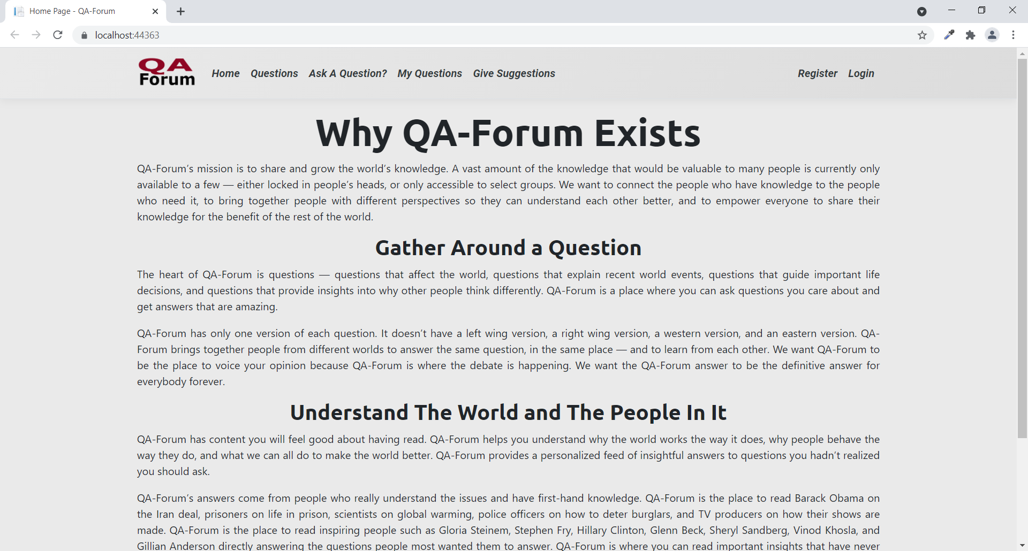

### Admin Subject View

With the help of this page, admin can view all subject available in forum

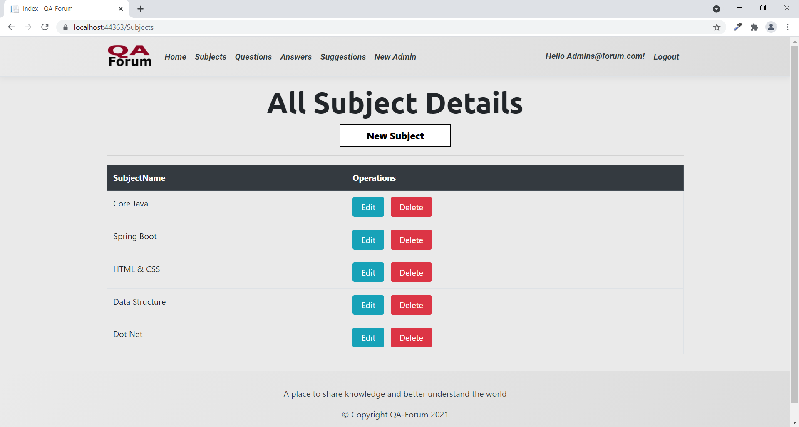

### Admin Question View

With the help of this page, admin can view all questions posted on forum.

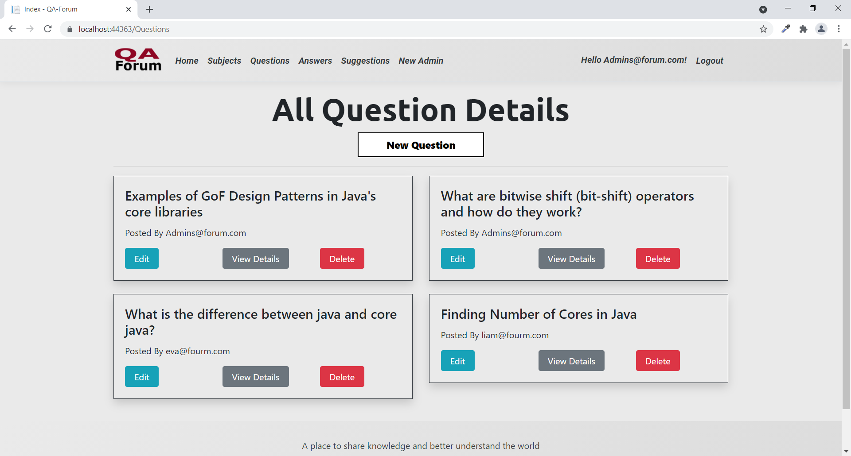

### Admin Question Details View

This page provides a way view a single question details view with their answers.

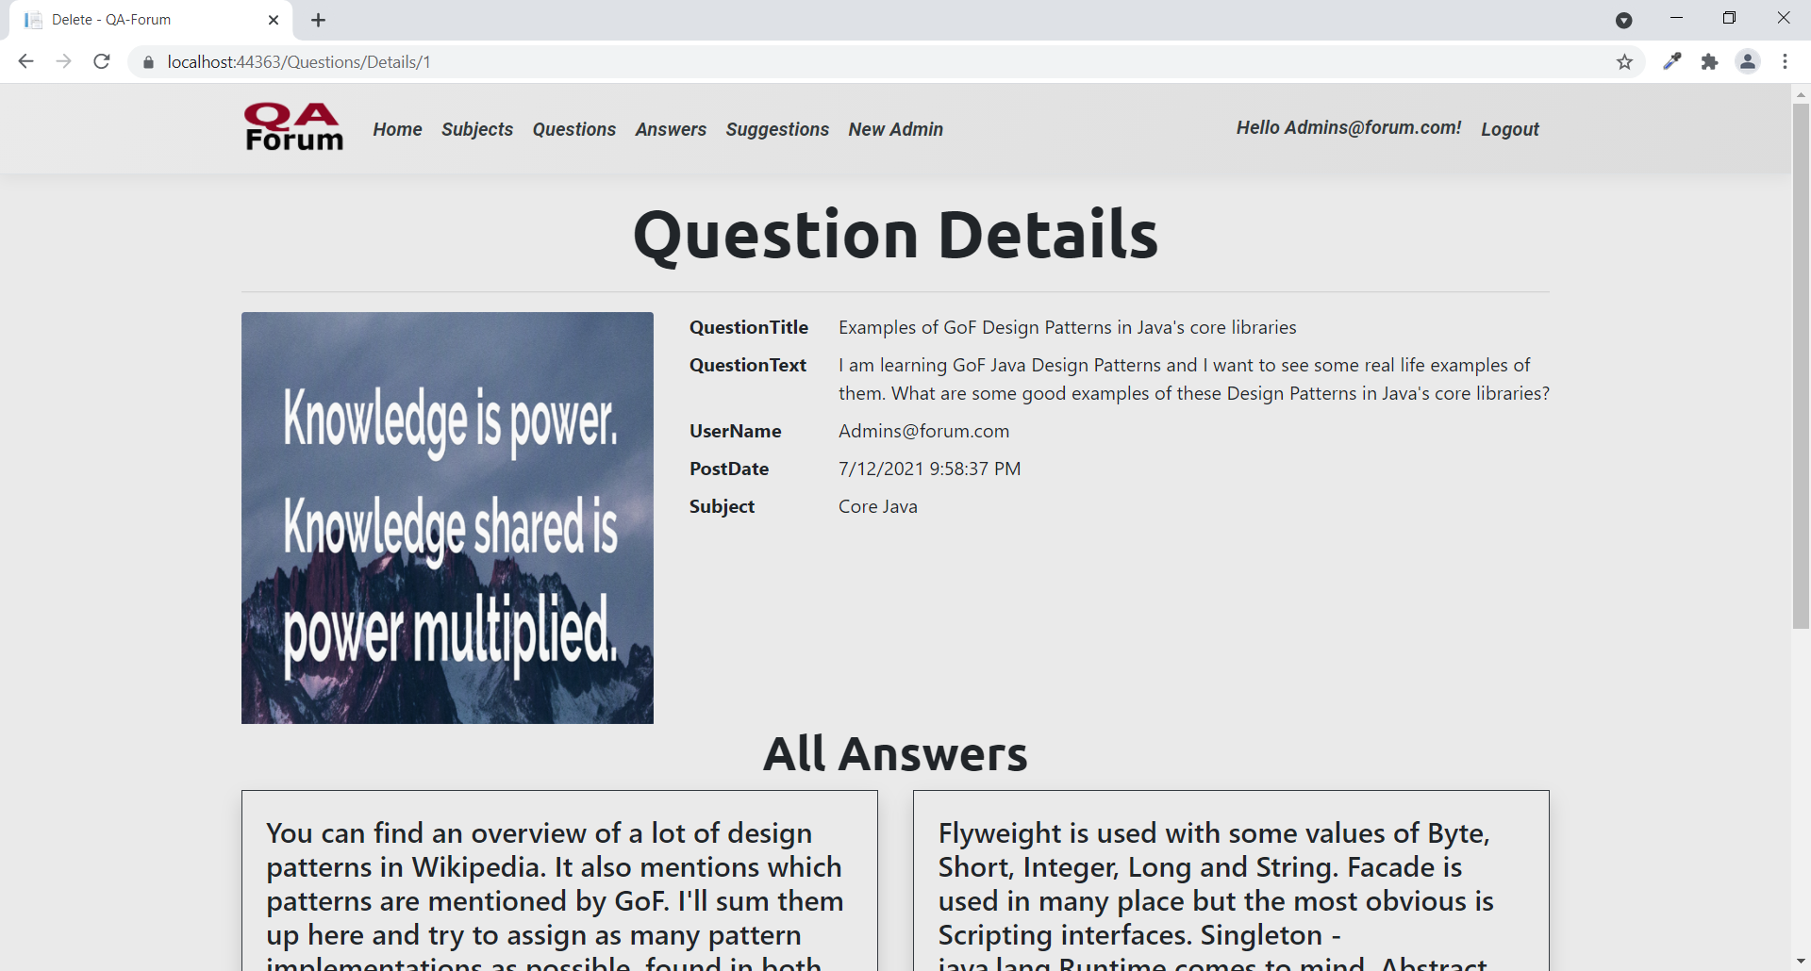

### 

### User All Question View

With the help of this page user can view all questions posted on forum.

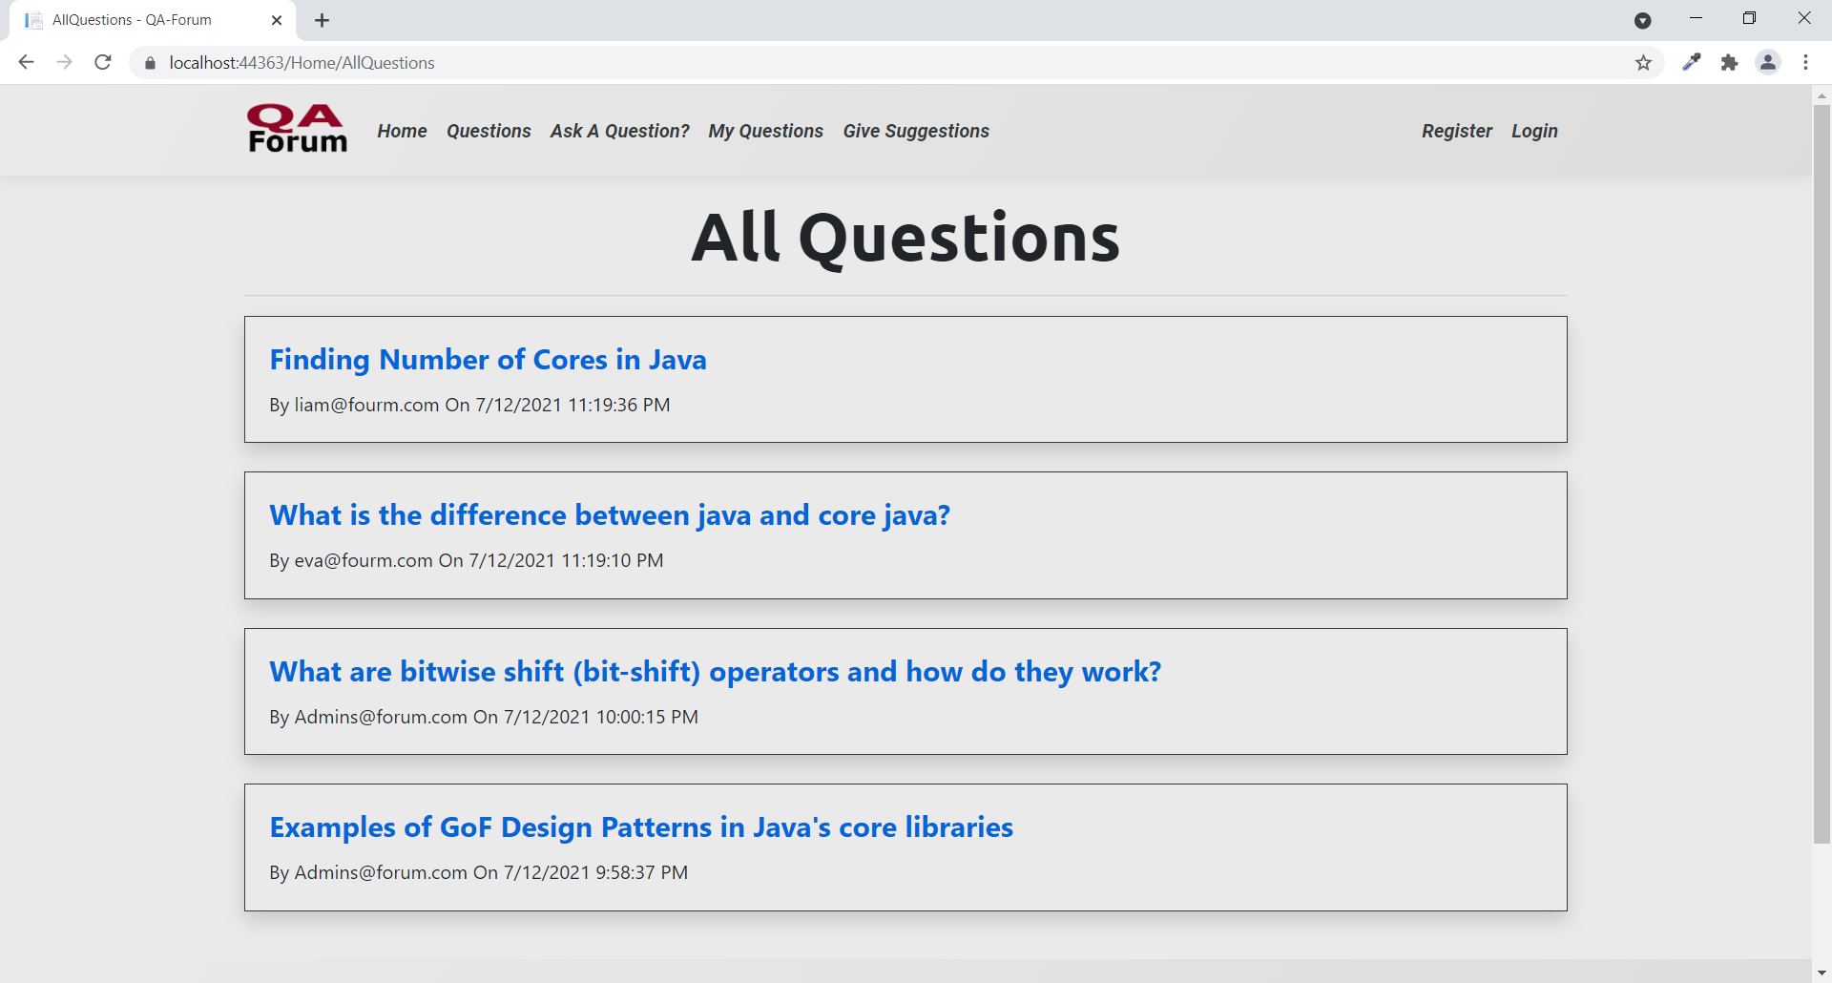

### User Question Details View

With the help of this page Visitor/Registered user can view a single question details view. 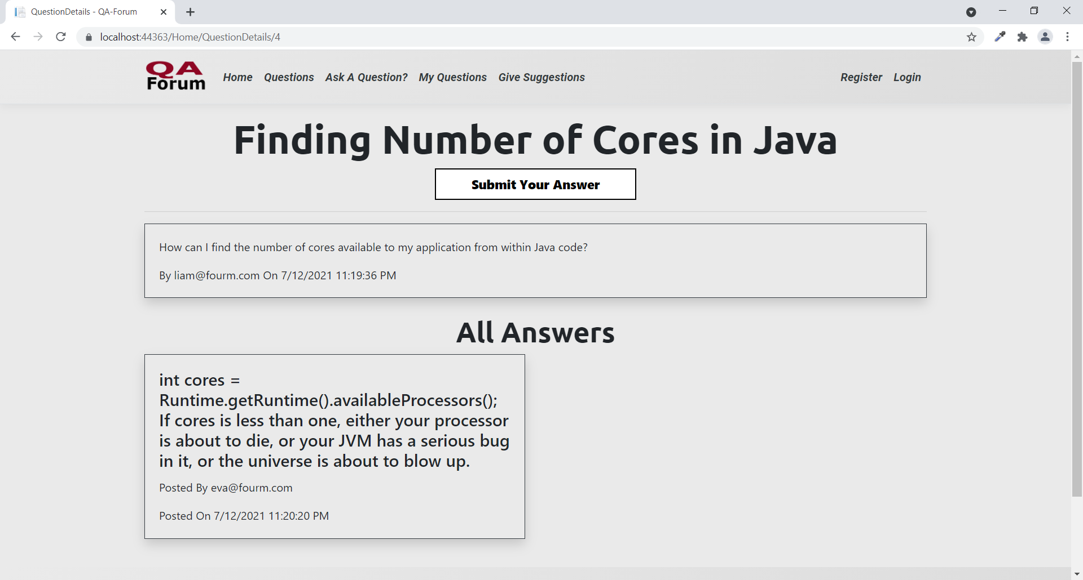

### User Ask a Question View

With the help of this page registered user can submit a question in forum.

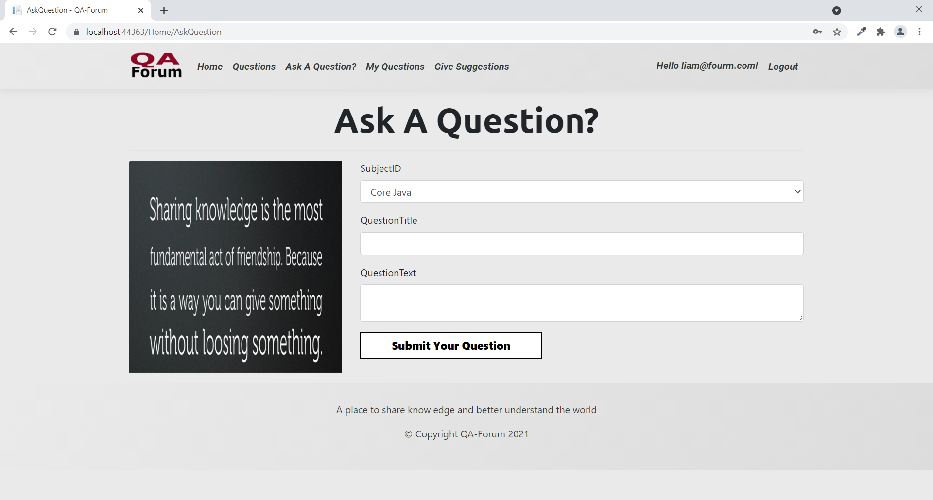

### Visitor Suggestion View

With the help of this page, visitor share his/her suggestion to forum.

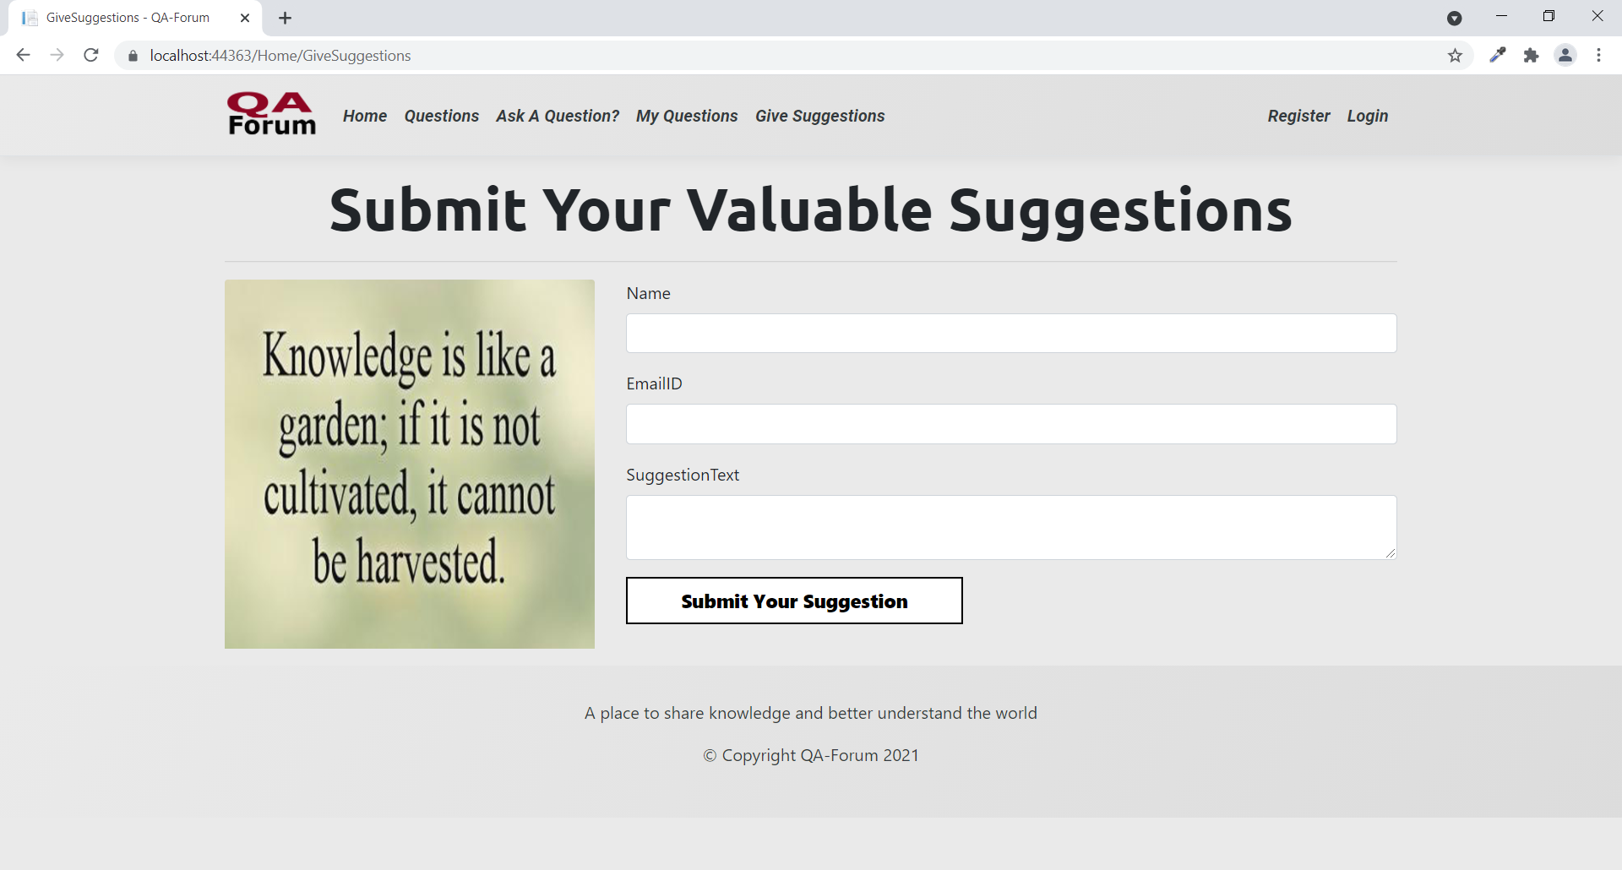

## Project Testing

The testing file for usability testing is attached as [usability test.xlsx](usability%20test.xlsx)

# User Manual

The main purpose of the application Forum Web App provide a single place person can share their wisdom as well as take the advantage of others. In this application there are two types of users- admin and registered user or visitor. Admin has different functionalities as compare to registered user. Admin can add, edit, delete and check details of subject and their questions. Admin also capable to remove some appropriate question as well as their answer. Registered User is capable to ask a question and submit their answer for question.

## Summary

### System Configuration

This app will be useful to for distributing mobile information in presentable format.

### User Access Levels

Only registered users can access the features of this application.

* **Admin:** Admin has full access of the app can register new admins.
* **Registered Visitor:** New visitor can register and existing can login using their own credentials. They have limited access.